

Name: BEECROFT ARNOLD OLUWATOBILOBA
Matric Number: COS/7437/2020 Supervisor/Mentor: Mr NIEMOGHA STAR Department: COMPUTER SCIENCE
Institution: FEDERAL UNIVERSITY OF PETROLEUM RESOURCES

Project Title: Neural Machine Translation for English-to-Itsekiri: A Digital Approach to Language Preservation

EXECUTIVE SUMMARY
Nigeria’s rich linguistic heritage faces an urgent threat, as indigenous languages like Itsekiri edge toward extinction due to limited documentation and dwindling usage among younger generations. This project aims to intervene by leveraging deep learning techniques specifically the T5 Transformer model to translate English into Itsekiri, thereby preserving the language.

To achieve this, a bilingual parallel corpus of English–Itsekiri sentences will be created and used to fine- tune the translation model. The trained model will be deployed in a web-based application built with Django, allowing users to input English and receive accurate Itsekiri translations in real-time. This fusion of AI and cultural preservation not only boosts the visibility of Itsekiri in digital spaces, but also sets the stage for further Natural Language Processing research into low-resource African languages. Ultimately, the project combines technology and tradition, fostering accessibility, education, and cultural pride for future generations

BACKGROUND STUDY
Language, as a vital aspect of culture, plays an essential role in daily life. It serves as a key identity marker for communities and remains one of the defining characteristics of national heritage.

In Nigeria, English has been the official language since colonial times. Its dominance has led to a gradual erosion of indigenous languages. This is because English language is used to teach children at school, English language is used in all sectors, judiciary, political, medical and even religion organization. This has brought significant cultural and linguistic consequences for national identity, leaving many children unable to communicate in their native language(Adeboje & Akinyede, 2025).

The increasing prestige of English in Nigeria is likely tied to its association with modernity, technological advancement, economic development, and global connectivity. Many native languages are slowly fading, as parents struggle to pass them on to their children, who often show little interest in learning them (Ikoba & Jolayemi, 2018).

Nigeria’s cultural diversity is reflected in the estimated 450 to 500 languages spoken across the country. However, while English remains the official language (Olawale Timothy et al., 2024), its prominence has contributed to the decline of indigenous languages such as Itsekiri, Yoruba, and Igbo (Adeboje & Akinyede, 2025).

To counteract this trend, a Neural Machine Translation model was developed to support low-resource indigenous languages. This technology enables the translation of English into native languages like Itsekiri using the Transformer model, which operates on an encoder–decoder architecture. Initially acclaimed for its excellence in machine translation, the Transformer has since become a foundational model for building advanced self-supervised systems in Natural Language Processing (Adeboje & Akinyede, 2025).

Neural Machine Translation therefore offers a valuable solution for preserving low-resource indigenous languages and promoting cultural identity in the digital age.

PROBLEM STATEMENT
Low resource Indigenous language such as Itsekiri are at risk of extinction due to limited data availability, which stems from a small number of native speakers and inadequate documentation efforts. Alarmingly, many young people, both within and outside of Delta State, are unable to speak or write in Itsekiri. This places the language in jeopardy of disappearing within the next three decades, especially as current native speakers age.

In contrast, English, with its extensive documentation and global reach, enjoys a significant advantage. While Itsekiri may have more speakers than writers, this imbalance further accelerates its decline.
However, the emergence of a Neural Machine Translation system built upon the Transformer model presents a compelling solution to the challenges facing low-resource languages like Itsekiri. This advanced technology facilitates the translation of English into Itsekiri, thereby playing a crucial role in preserving the language by teaching people how to read and write in Itsekiri.

AIM/OBJECTIVE
To design and implement a web-based translation system capable of converting English text to Itsekiri, using neural machine translation techniques powered by the T5 model. The study’s objectives are as follows:
- To build a parallel bilingual corpus comprising English–Itsekiri translation pairs suitable for model training and evaluation.
- To fine-tune the pre-trained T5 transformer model using the constructed corpus for optimal translation accuracy.
- To develop and deploy a user-friendly web application that integrates the trained model for real-time English–Itsekiri translation.

CONCEPTUAL REVIEW
Preserving linguistic diversity is vital for maintaining cultural heritage and identity, as many communities risk losing their linguistic identity due to underrepresentation in digital resources. Neural Machine Translation (NMT), powered by deep learning, enables accurate and natural translations between languages. This review explores NMT, with a focus on the Transformer model, for translating English to a low-resource language, addressing the challenges of limited digital representation.

(Konyk et al., 2023) aim to to develop and evaluate a novel Ukrainian-English machine translation system based on recurrent neural networks, focusing on its effectiveness compared to existing solutions like Google Neural Machine Translation, Microsoft Translator, and OpenNMT. By conducting a comparative analysis of their advantages and disadvantages, the study seeks to define the main functional requirements and technical specifications for an intelligent translation system, with the goal of optimizing performance and addressing limitations observed in the neural network model after 25 epochs of training.

Furthermore, (Olawale Timothy et al., 2024) proposes to develop a Bilingual Neural Machine Translation from English to Yoruba using a Transformer Model to address the limitation of using a Recurrent Neural Network(RNN).

In addition, (Ekle & Das, 2025) research aim to develop Neural Machine Translation (NMT) and Transformer-based transfer learning models for English-to-Igbo by using Recurrent Neural Network (RNN) architectures, including Long Short-Term Memory (LSTM) and Gated Recurrent Units (GRU), enhanced with attention mechanisms to improve translation accuracy. To further enhance performance, we apply transfer learning using MarianNMT pre-trained models within the Simple Transformers framework.

Going Further, (Adeboje & Akinyede, 2025), aim to translate English to Yoruba Language by utilizing a Transformer model that used Bidirectional Encoder From Transformers(BERT) for the Encoder and Text- to-Text Transfer Transformer(T5) for the Decoder.

Additionally, (Gbelewade, 2025) aim to develop and evaluate a specialized machine translation system for translating STEM(Science Technology Engineering and Mathematics) content from English to Yoruba, leveraging transformer-based neural machine translation techniques to improve accessibility to scientific and technical knowledge for Yoruba speakers.

LITERATURE REVIEW

Author- Date-Title | Objectives | Methodology Used | Strengths | Gaps/Further Studies
(Konyk et al., 2023),  Technology of Ukrainian- English Machine Translation Based on Recursive Neural Network as LSTM | To develop a English to Ukraine Neural Machine Translator and also do a comparative analysis with analogues like Google NMT. OpenNMT and Microsoft Translator. | Recurrent Neural Network(RNN) following a Seq2Seq model with the use of Long Short Term Memory(LSTM) layer. | - Utilizes neural machine processes for quicker training compared to rule- based NMT, reducing manual effort.  - Built using Python, Keras, and TensorFlow, benefiting from robust libraries and scalability for neural network development. | Future research should focus on enhancing translation accuracy through exploring alternative or additional architectural solutions
(Olawale Timothy et al., 2024),  Bilingual Neural Machine Translation From English To Yoruba Using A Transformer Model | To address the limitations of using Recurrent Neural Network(RNN) for translation. | Transformer model with BERT for the Encoder and T5 for the Decoder. | - Employs word piece tokenization, positional, segment, and token embeddings for robust input processing.  - Enhances training stability and performance through layer normalization and residual connections in FFN. | Insufficient focus on Yoruba’s tonal and morphological features, which could lead to translation errors.

(Adeboje & Akinyede, 2025), A  Deep Learning- based English to Yoruba Neural Translation Model. | To Develop a Yoruba Neural translator that translate English to Yoruba, in order to prevent the gradual decline of Yoruba. | Transformer model which is neural machine translation module. | - Contributes to NMT for underrepresented languages.  - Eliminates Vanishing gradient by making use of residual connection | - No use of Evaluation metric like BLEU(Bilingual Evaluation Understudy) or Native Speakers.
(Ekle & Das, 2025), Low-  Resource Neural Machine Translation Using Recurrent Neural Networks and Transfer Learning: A Case Study on English- to-Igbo | Neural Machine Translation (NMT) and Transformer- based transfer learning models for English-to- Igbo translation | Recurrent Neural Network (RNN) architectures, including Long  Short-Term Memory (LSTM) and Gated Recurrent Units (GRU), enhanced with attention mechanisms and transfer learning to improve translation accuracy. | - Achieves a BLEU score of 0.3817 with LSTM-based model and 0.43 with transfer learning, surpassing benchmarks  - Incorporates dot- product and global attention, enhancing translation accuracy for long and complex sentences. | - Model loss  (0.602) suggests incomplete convergence after 20 epochs, additional epochs (10-20) could yield further improvements.  - Trained on 597 sentence pairs for transfer learning; larger datasets could improve robustness and generalization
(Gbelewade, 2025)  Science in Mother tongue: English-to- Yoruba STEM  translation. | To develop and optimize machine translation models for the translation of Science, Technology, Engineering, and Mathematics (STEM) contents from English to Yoruba | A combination of deep learning techniques e.g Transfer and agile project management methodologies | - Preserves Yoruba language in STEM education  - Fine-tuned mT5 model for STEM- specific translation, achieving 36.08 BLEU score | - Limited parallel corpora  - Terminology inconsistencies

GAPS IDENTIFIED VIS-À-VIS TECHNOLOGY/METHOD TO RESOLVE THE IDENTIFIED GAPS
According to (Adeboje & Akinyede, 2025) aims to develop an English-to-Yoruba neural translation model but faces high error rates, limited parallel corpora, tonal/morphological complexities, and inadequate positional embeddings. Solutions include robust preprocessing, transformer models, regularization, back-translation, transfer learning with mBART, crowdsourced data, tone-aware/BERT embeddings, custom loss functions, relative positional encodings, and multi-head attention to boost accuracy and preserve Yoruba.

Also, (Gbelewade, 2025) aims to develop an English-to-Yoruba STEM translation model but faces gaps like limited parallel corpora, Yoruba’s tonal and morphological complexities, high terminology and notation errors, and inconsistent performance across STEM domains. Proposed solutions include data augmentation through web scraping from Yoruba Sciepedia and PDF extraction, fine-tuning mT5 models with STEM-specific data, tone-aware tokenization, Unicode normalization, and BLEU scores with category-specific evaluations to enhance accuracy and consistency.

METHODOLOGY

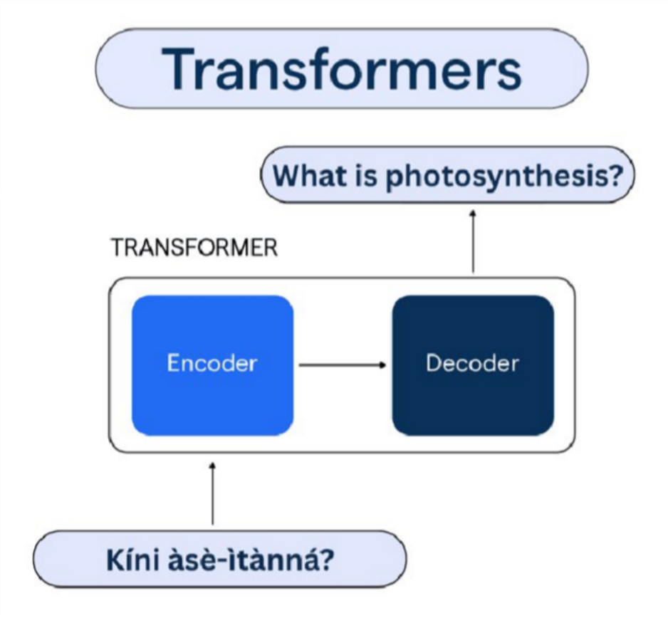
Figure 1: Translation process overview(Source((Gbelewade, 2025))

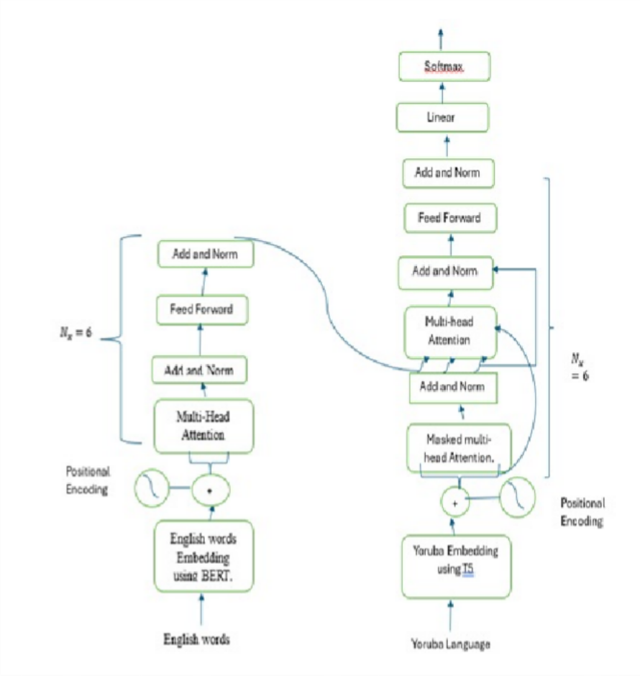
Figure 2: The Architecture of the developed model (Source(Adeboje & Akinyede, 2025))

For the purpose of this work, the methodology of (Adeboje & Akinyede, 2025) and (Gbelewade, 2025) will be partially adopted. The methodology involves the use of the Text-to-Text Transfer Transformer (T5) model to translate English text into Itsekiri. To tailor the model for this specific language pair, it will be fine-tuned using a custom English–Itsekiri parallel corpus.
T5 functions as a sequence-to-sequence model with an encoder–decoder architecture. The encoder converts the English input into contextual embeddings, while the decoder generates the corresponding Itsekiri output. Multi-head attention is applied during decoding to enhance translation quality by focusing on different parts of the input simultaneously.
Upon completion of training and fine-tuning, the model will be deployed as an API. This will enable external applications to send English text and receive translated Itsekiri responses. A web application developed with the Django framework will act as the frontend interface.

Through this platform, users will input English text, which will be routed to the API. The translated Itsekiri output will then be retrieved and displayed.

EXPECTED RESULT / OUTCOME
The proposed study is expected to deliver the following key outcomes:
- Web Application Deployment A responsive web-based application will be developed and deployed to facilitate seamless translation from English to Itsekiri. This tool will be user-friendly and accessible across multiple devices.
- T5 Model Fine-Tuning The T5 Transformer model will be fine-tuned using a custom-built English–Itsekiri parallel corpus. This process will ensure contextually accurate translations that honor the linguistic structure and cultural nuances of the Itsekiri language.
- Expansion of NLP Resources The project will lay the groundwork for further research and development in Itsekiri Natural Language Processing (NLP) by providing foundational resources such as annotated datasets, translation benchmarks, and model outputs.
- Preservation and Promotion of the Itsekiri Language By incorporating Itsekiri into a modern digital framework, this tool will enhance the representation of the language in NLP(Natural Language Processing). It will also contribute to preserving and promoting Itsekiri for future generations through accessible technological means.

WORK-PLAN/TIME FRAME USING GANTT CHART
This research will span for a period of 3 months spanning from July 2025 to September 2025

Description | Time Line from July 2025 –September2025
 | JULY | AUGUST | SEPT.
Study of Existing System/Data Collection
Model Development/Programming
Implementation/Testing
Report Writing

The implementation of this project will follow a structured workflow consisting of the following stages:

- Corpus Development Collection and creation of a bilingual parallel corpus for English–Itsekiri translation, serving as the foundational dataset for model training.
- Model Development Construction of a Neural Machine Translation system using the T5 transformer model, fine-tuned with the custom corpus for accurate language conversion.
- Web Application Development Design and implementation of a responsive web application using the Django framework, enabling user interaction and access to the translation service.
- System Testing Evaluation of the translation system's performance and usability through rigorous functional testing and validation of translation accuracy.
- Documentation and Reporting Preparation of a detailed technical report outlining the methodology, system architecture, results, and key findings of the project.

BUDGET

Item | Description | Cost (NGN)
Internet Access | Data for research, coding and model fine-tuning | 30,000
Development Environment | A personal laptop, which I’ll be borrowing from a friend during the project, will serve as my primary workstation. | 35,000
Cloud Computing (Training) | Google Colab Pro for T5 model fine-tuning | 15,275
Dataset Acquisition | Crowdsourced Itsekiri-English parallel data collection from Native Speakers and students learning Itsekiri language as a course at College of Education Warri | 85,000
Transportation | Travelling within and outside  of warri for Gathering of Data. | 23,600
Domain Name(optional) | .com per year | 15,250
Fuel | Due to lack of Electricity , Fuel will be needed to power up  the generator | 45,000
Report Printing | Printing of report or Project  Paper | 29,500
Front-End Developer | The developer that would write the code for the  frontend | 10,000
Miscellaneous | Unexpected Expense | 15,000
Total |  | ₦ 303,625

REFERNCES
Adeboje, O. T., & Akinyede, R. O. (2025). A Deep Learning-based English to Yoruba Neural Translation Model. 186(62), 38–41.

Nzeaka, E., & Ehondor, B. (2021). Urbanisation and Endangered African Indigenous Tongues : The Urbanisation and Endangered African Indigenous Tongues : The Case of Igbo Language in Nigeria. June.

Ikoba, N., & Jolayemi, E. T. (2018). A Stochastic Model of Indigenous Language Extinction in Nigeria A Stochastic Model of Indigenous Language Extinction in Nigeria. August.

Etim-James, G., & Ubi, U. (2024). The Impact of Globalization on Nigerian Culture and Language: A Study of Ekid Language. Policy and Governance Research (JPAPGR), 2(2), 22–28.

Konyk, M., Vysotska, V., Goloshchuk, S., Holoshchuk, R., Chyrun, S., & Budz, I. (2023). Technology of Ukrainian-English Machine Translation Based on Recursive Neural Network as LSTM. CEUR Workshop Proceedings, 3387, 357–370.

Ekle, O. A., & Das, B. (2025). Low-Resource Neural Machine Translation Using Recurrent Neural Networks and Transfer Learning: A Case Study on English-to-Igbo. April. https://doi.org/10.48550/arXiv.2504.17252

Oparinde, K. M. (2017). Language Endangerment: The English Language Creating a Concern for the Possible Extinction of Yorùbá Language. Journal of Communication, 8(2), 112–119. https://doi.org/10.1080/0976691x.2017.1396006

Muhammad, S. H., Ahmad, I. S., Abdulmumin, I., Lawan, F. I., Sani, B., Imam, S. H., Aliyu, Y., Sani, S. A., Umar, A. U., Gwadabe, T., Church, K., & Marivate, V. (2025). HausaNLP: Current Status, Challenges and Future Directions for Hausa Natural Language Processing. http://arxiv.org/abs/2505.14311

Liu, D., Li, Y., Zhu, D., Liu, X., Ma, N., & Zhu, A. (2020). Investigating Back-Translation in Tibetan-Chinese Neural Machine Translation. Journal of Physics: Conference Series, 1651(1). https://doi.org/10.1088/1742-6596/1651/1/012122

Raffel, C., Shazeer, N., Roberts, A., Lee, K., Narang, S., Matena, M., Zhou, Y., Li, W., & Liu, P. J. (2020).
Exploring the limits of transfer learning with a unified text-to-text transformer. Journal of Machine Learning Research, 21, 1–67.

Tamrin, Zalmansyah, A., Yance, I., Asri B., M., Karsana, D., Harum, D. M., Supriadi, A., Yono, S., Hidayat, S., & Wardhani, A. (2025). Endangered Language: Preserving Totoli Language and Cultural Identity. Theory and Practice in Language Studies, 15(6), 1885–1897. https://doi.org/10.17507/tpls.1506.17

M.M., O., & Noah, P. (2021). Cultural Dominance and Language Endangerment: The case of Efut in Cross River State, Nigeria. Macrolinguistics, 9(14), 134–150. https://doi.org/10.26478/ja2021.9.14.8

Olawale Timothy, A., Olusola Adebayo, A., Gabriel Junior, A., & Raphael Olufemi, A. (2024). Bilingual Neural Machine Translation From English To Yoruba Using A Transformer Model. International Journal of Innovative Science and Research Technology (IJISRT), July, 826–833. https://doi.org/10.38124/ijisrt/ijisrt24jul767

Wijerathna, L., Somaweera, W. L. S. L., Kaduruwana, S. L., Wijesinghe, Y. V., De Silva, D. I., Pulasinghe, K., & Thellijjagoda, S. (2012). A Translator from Sinhala to English and English to Sinhala (SEES).
International Conference on Advances in ICT for Emerging Regions, ICTer 2012 - Conference Proceedings, August, 14–18. https://doi.org/10.1109/ICTer.2012.6421408

Mohiuddin, K., Welke, P., Alam, M. A., Martin, M., Alam, M. M., Lehmann, J., & Vahdati, S. (2023).
Retention Is All You Need. International Conference on Information and Knowledge Management, Proceedings, Nips, 4752–4758. https://doi.org/10.1145/3583780.3615497

Gbelewade, A. (2025). Science in Mother tongue : English-to-Yoruba STEM translation Department of Computer Science BSc ( Hons ) Computer Science Academic Year 2024 - 2025 Science in Mother tongue : English-to-Yoruba STEM. April. https://doi.org/10.13140/RG.2.2.28868.13442

